**Output for mAadhar Application.**

**DESCRIPTION**

**Problem statement:**

**Develop an application to automate the process of applying for an Aadhar Card by making it smoother for Indian citizens.**

***Screenshots:***

**Creating database in mysql:**

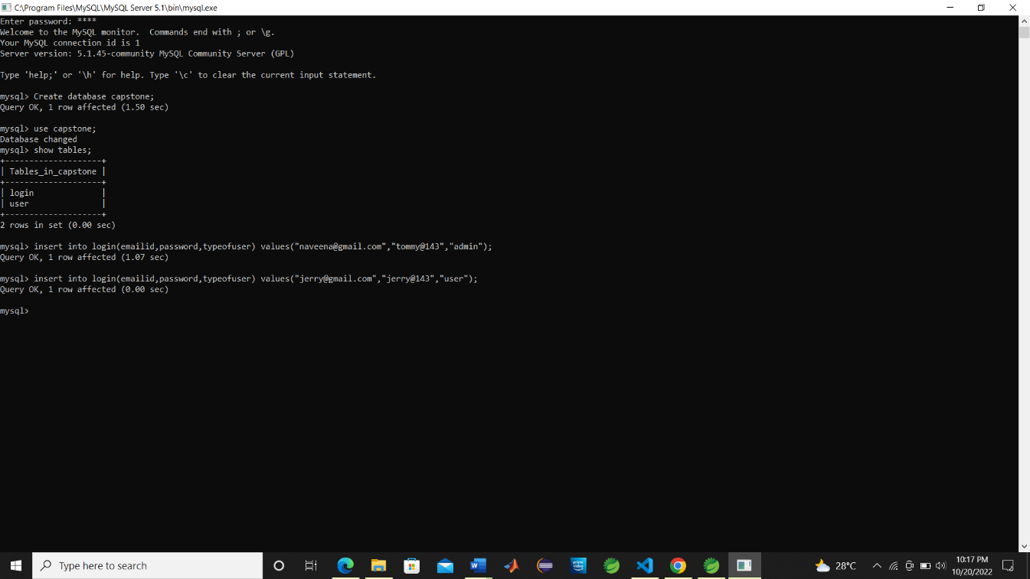

**Running in eclipse:**

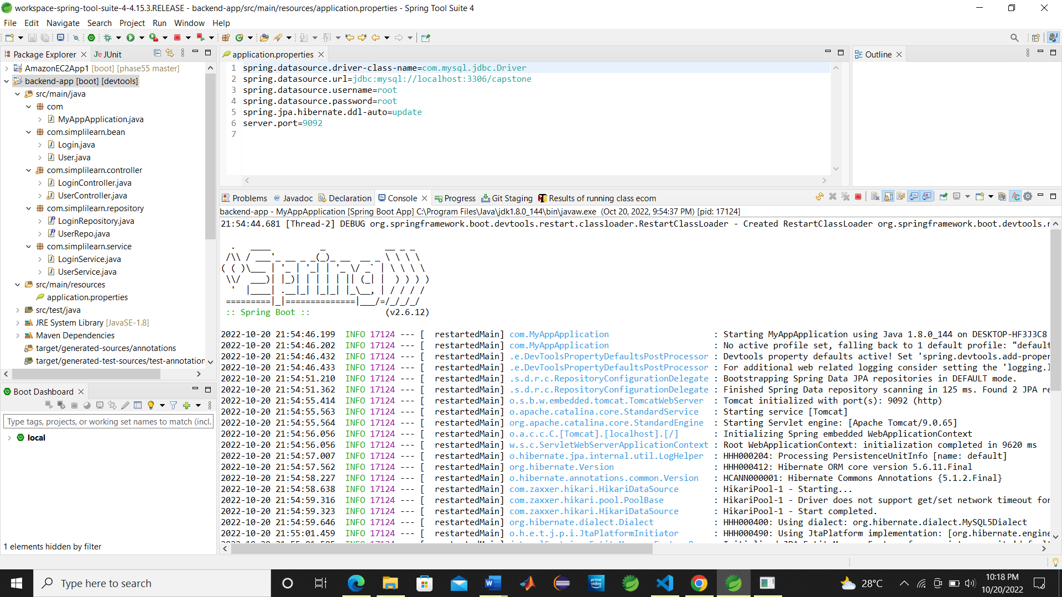

**localhost:4200 :**

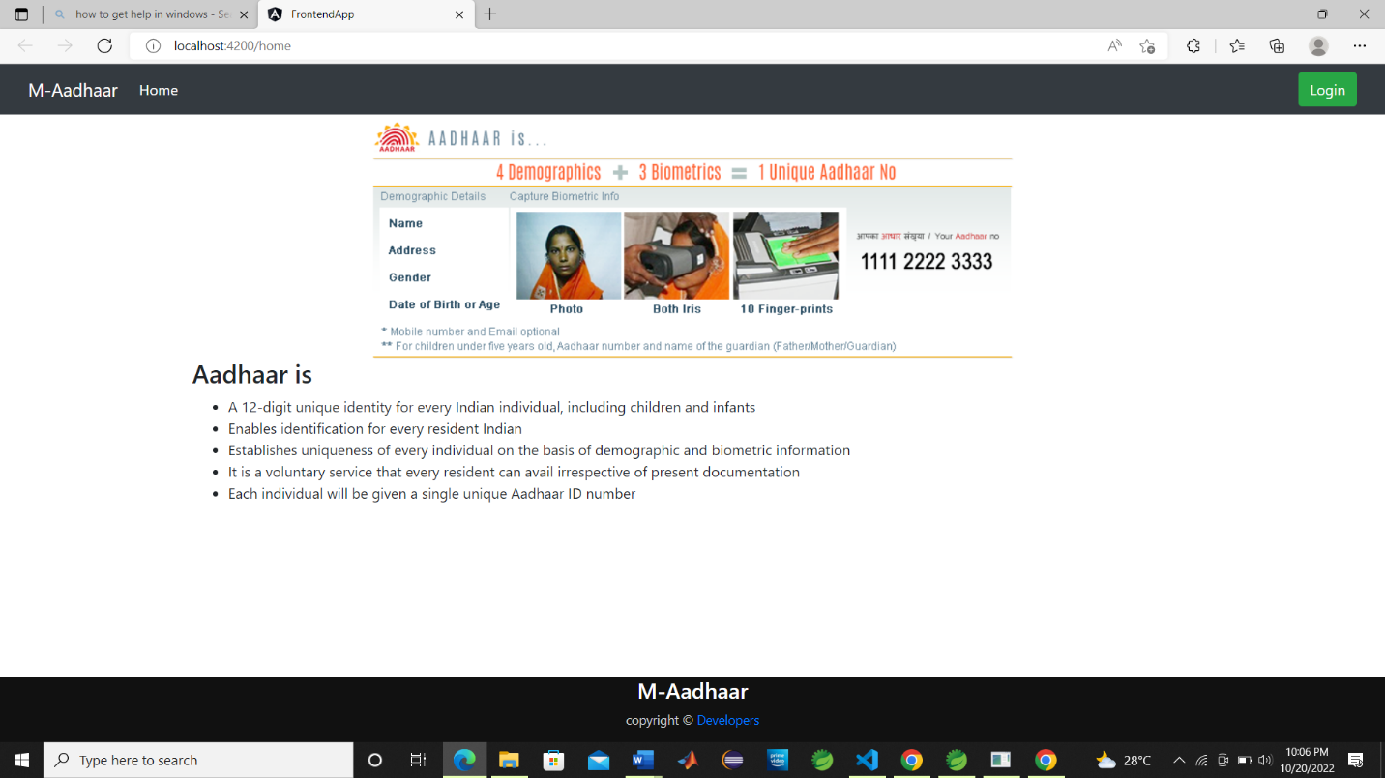

**Once we click login:**

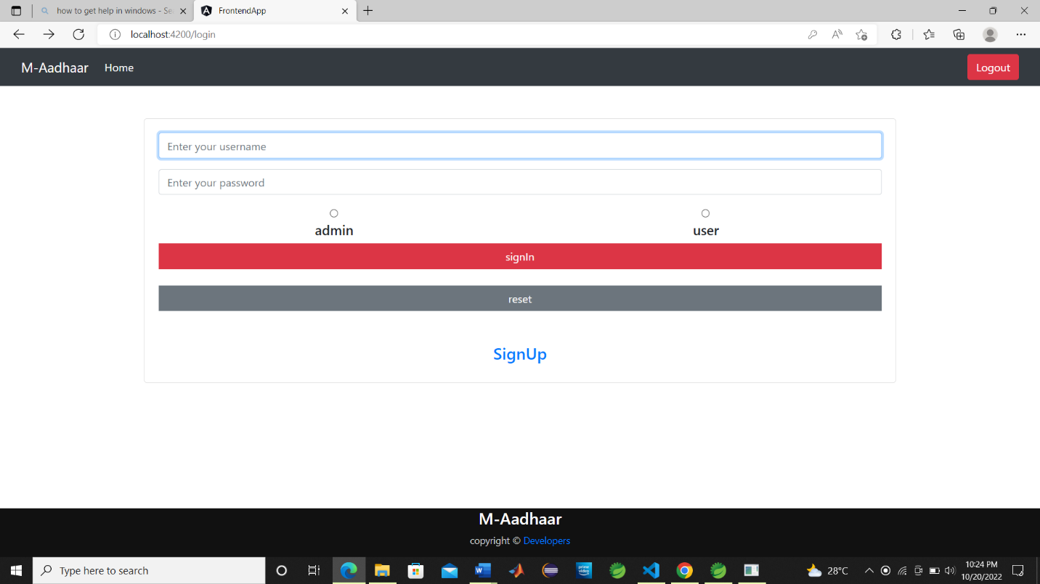

**Given admin credentials:**

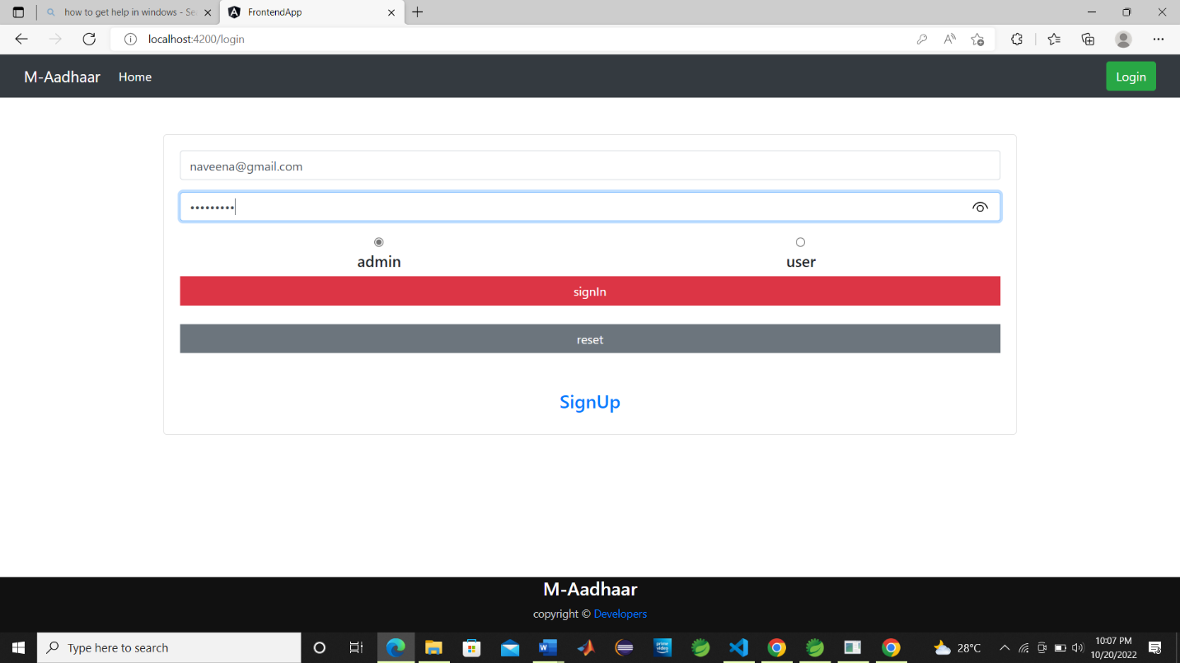

**After signin as admin:**

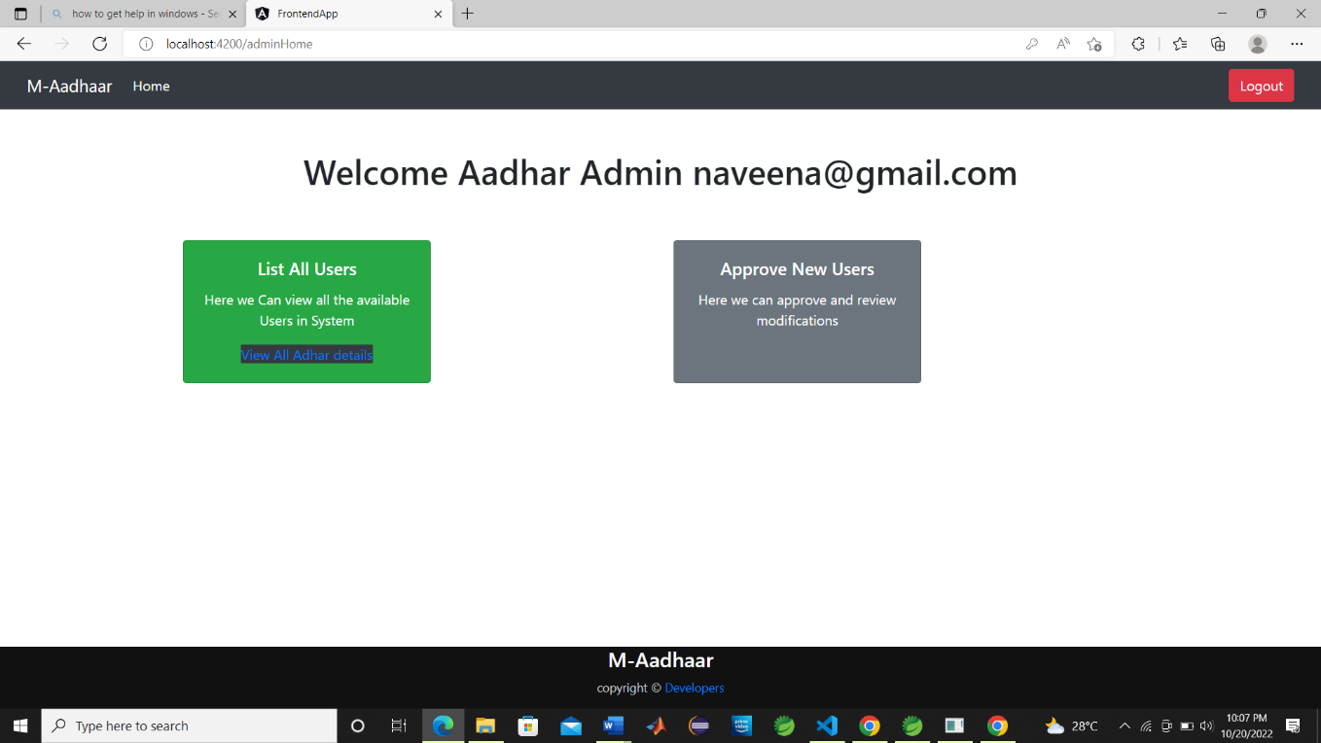

**If you are a new user comeback to login page and click on signup to create account:**

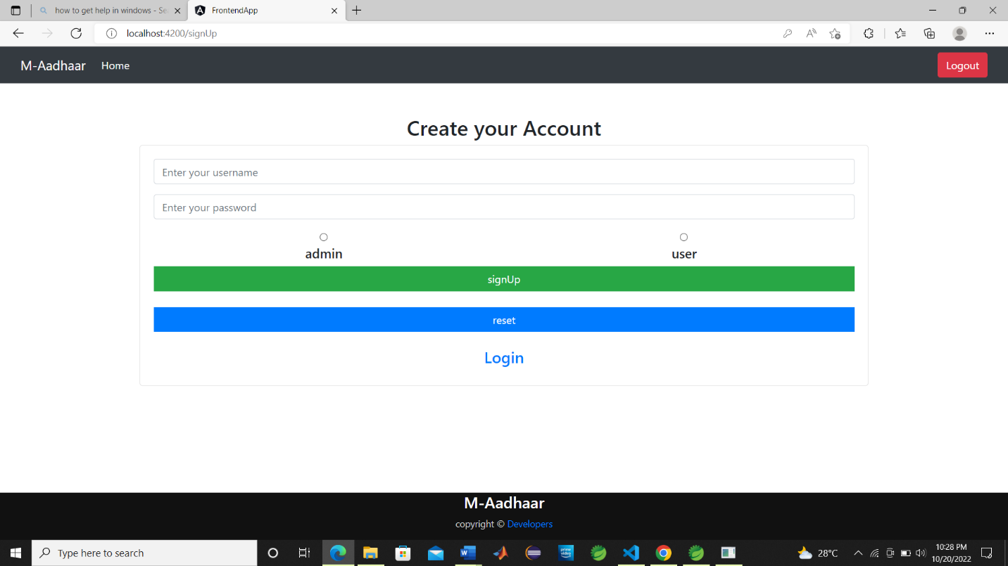

**Creating an account as an user:**

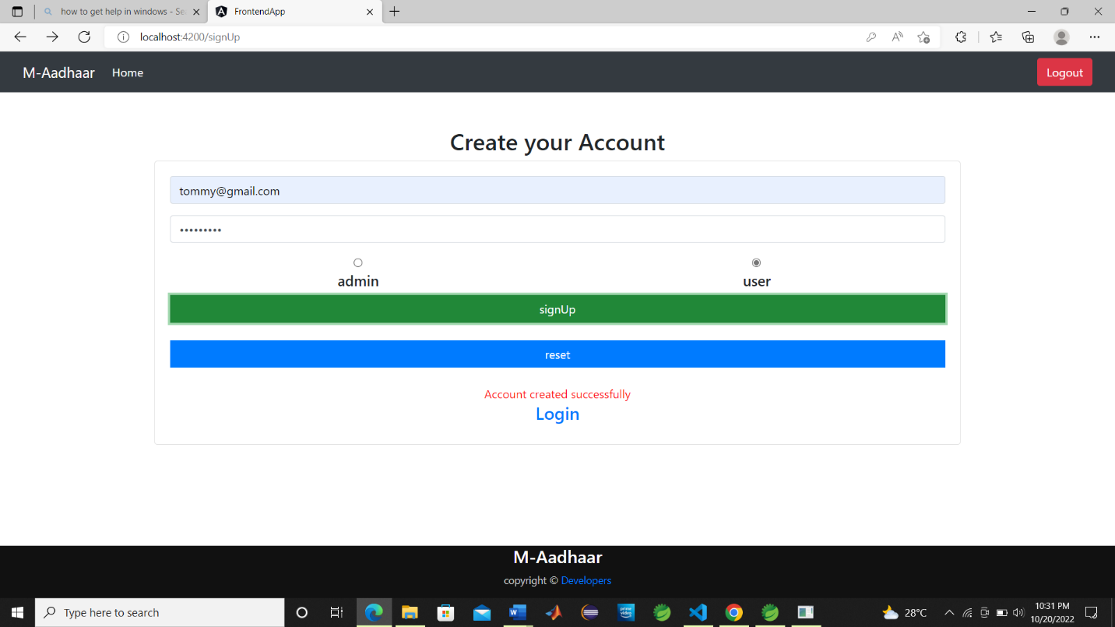

**After creating an user account again signin with user credentials:**

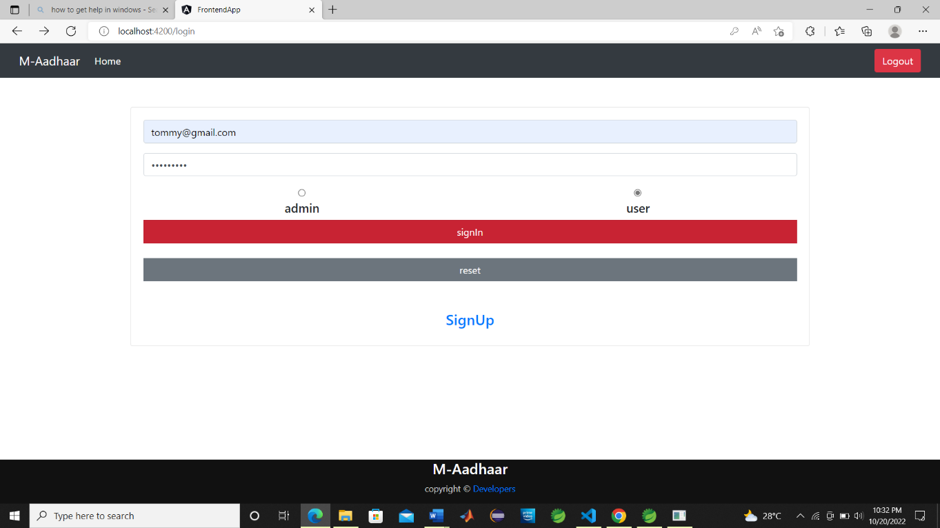

**After user login:**

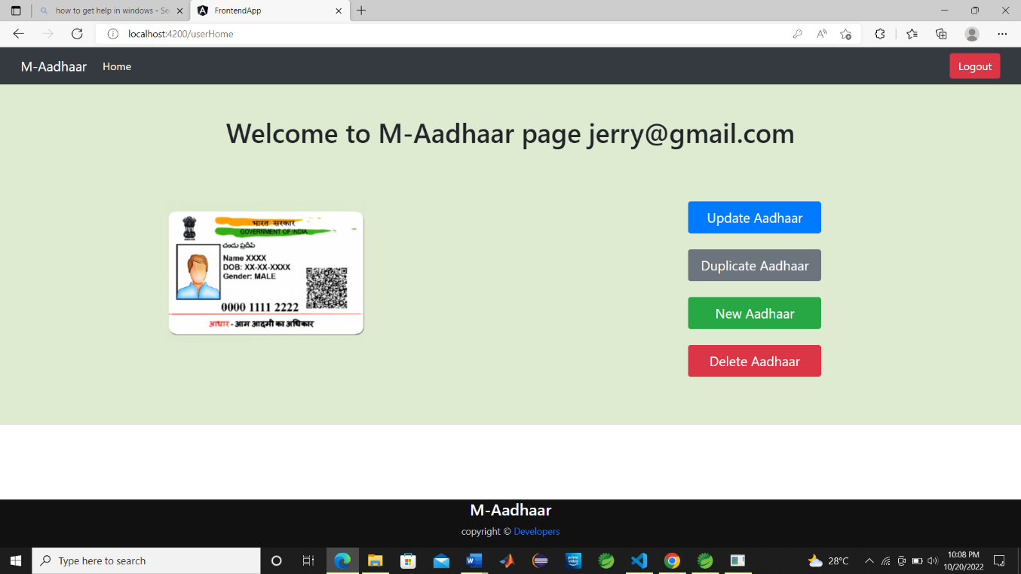

**If user click New Aadhar button:**

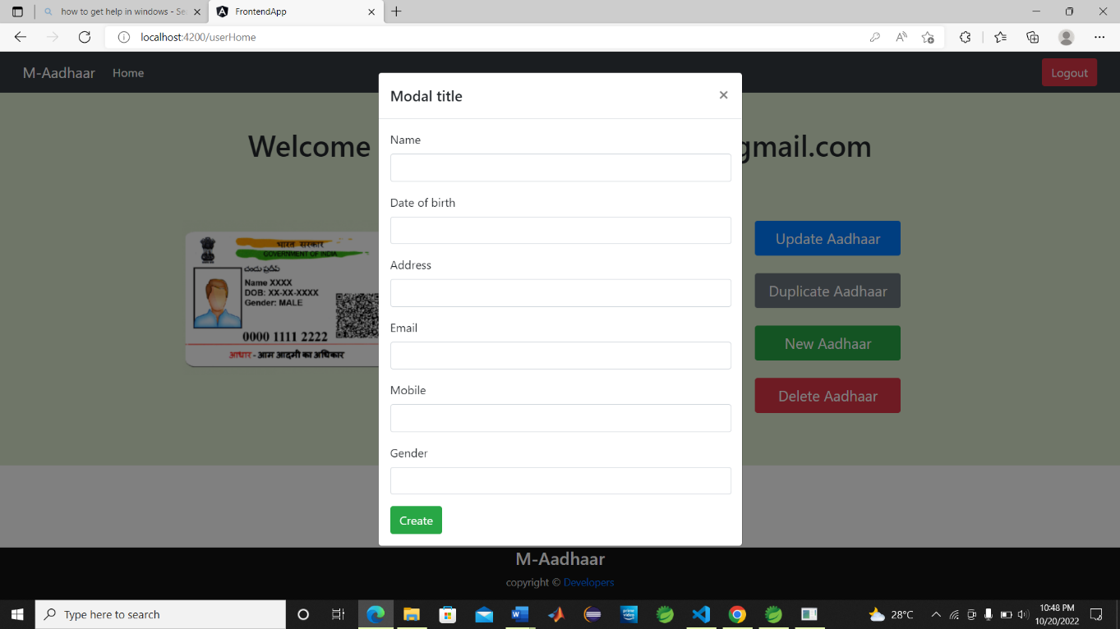

**After entering details:**

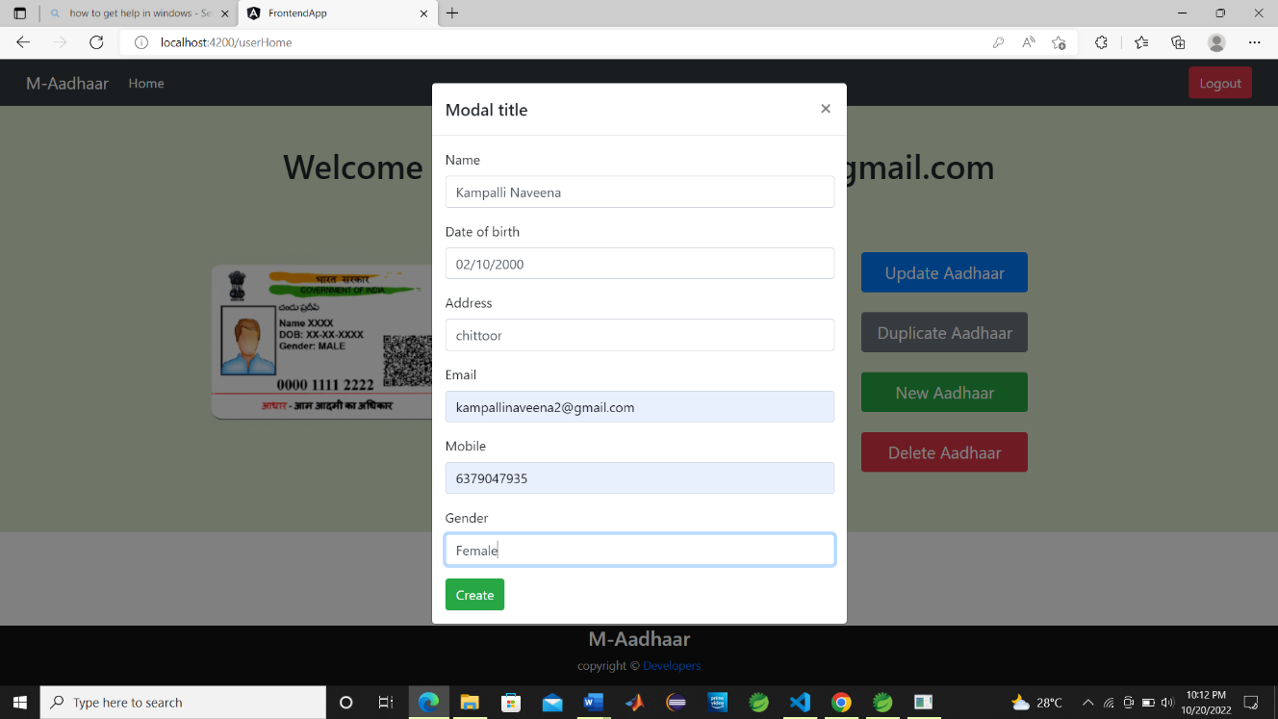

**After clicking create button:**

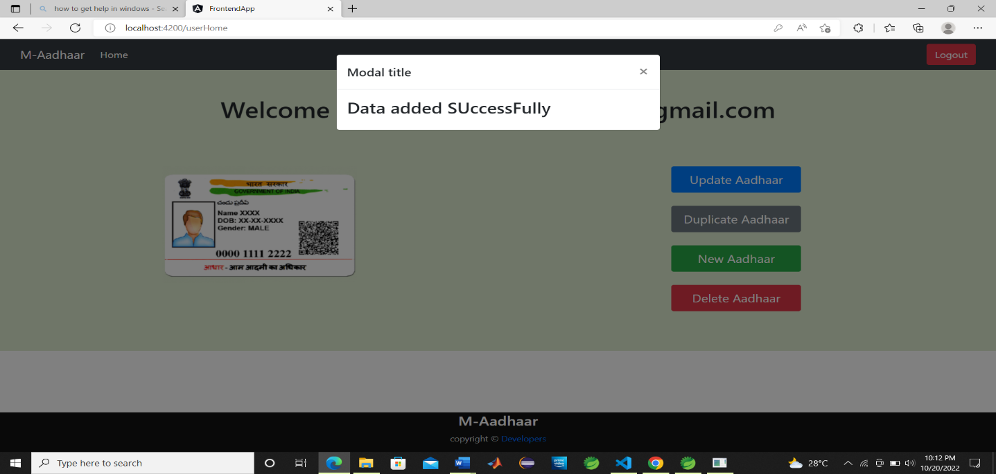

**If user click Duplicate Aadhar button:**

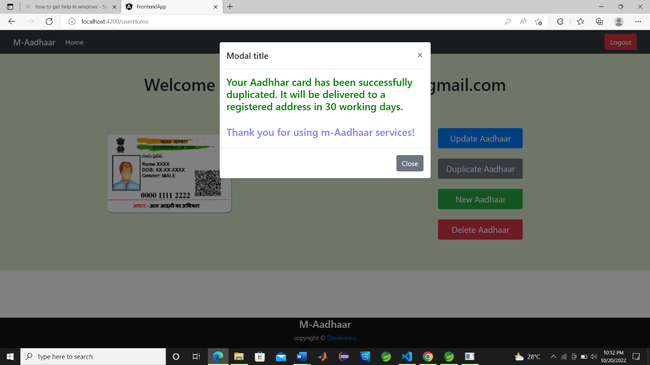

**If user click Delete Aadhar button:**

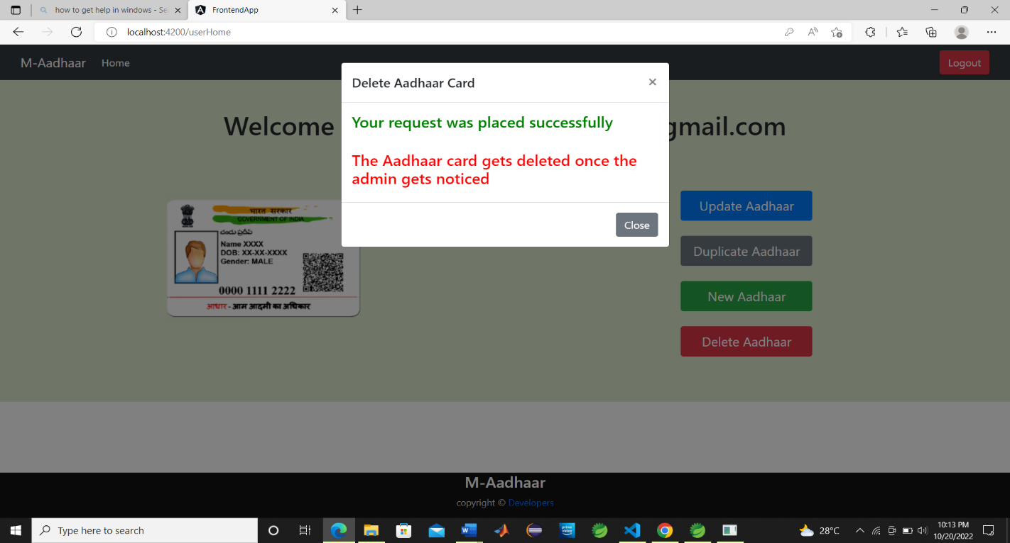

**If the user click Update Aadhar button:**

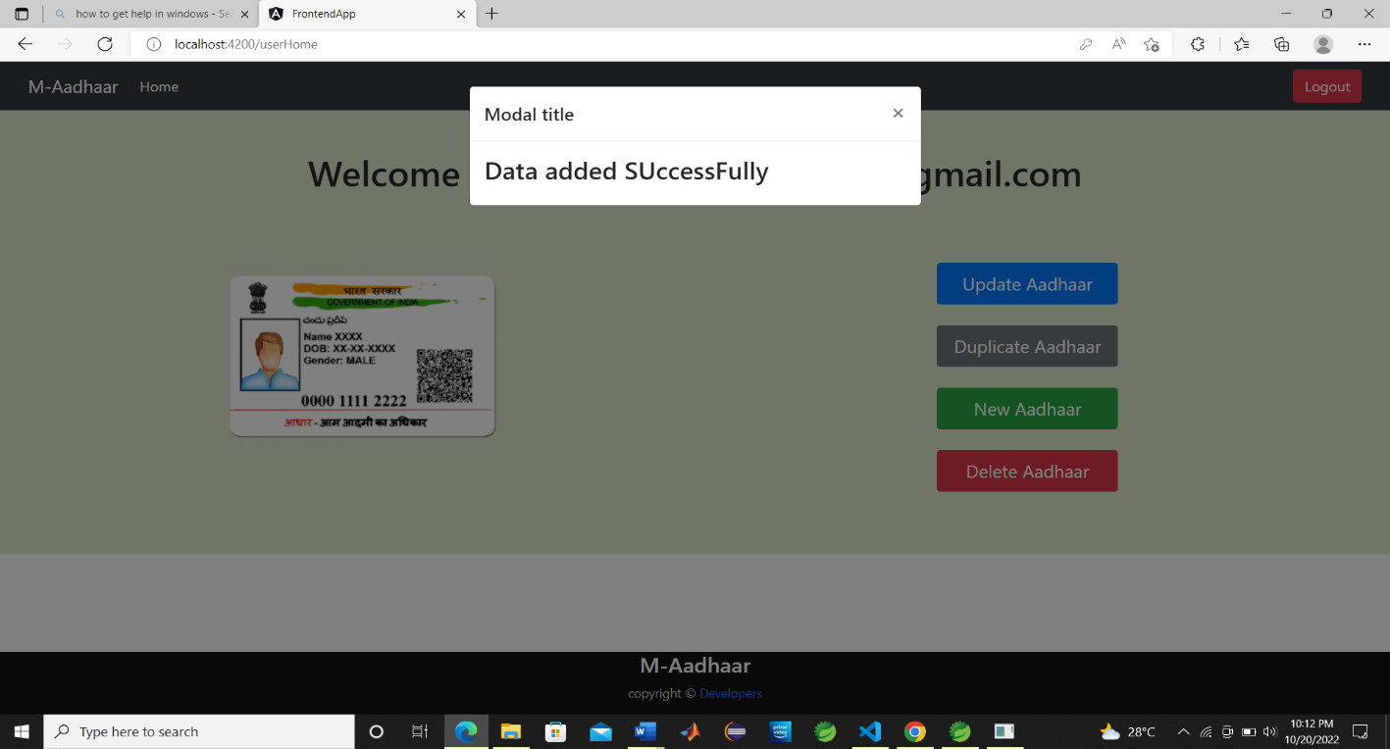

**Again admin login:**

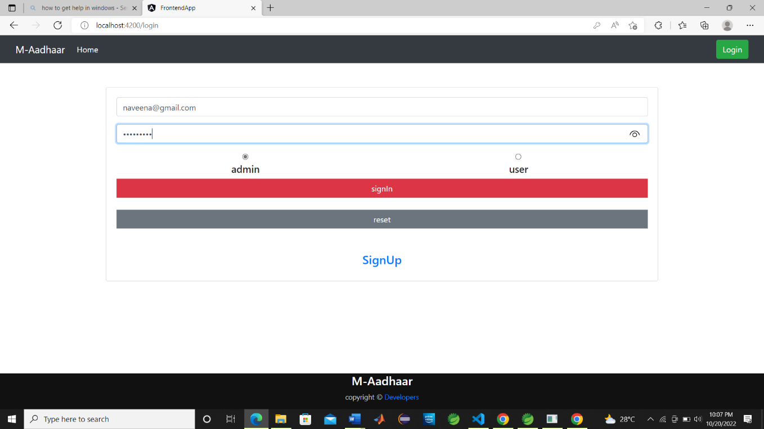

**If admin click list all users:**

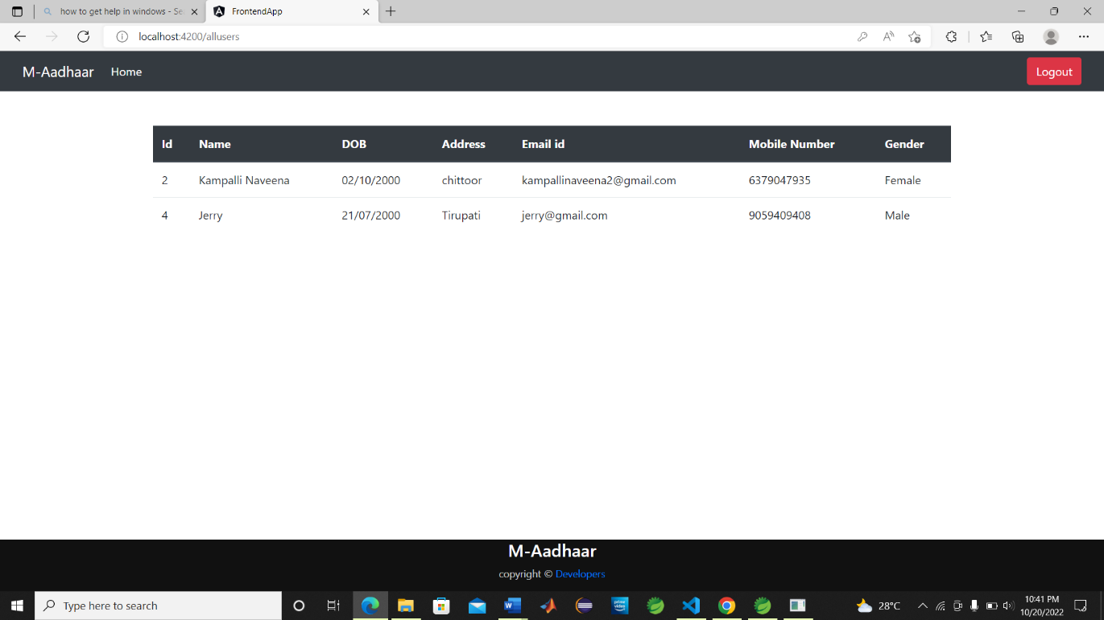

**If admin click approve user requests:**

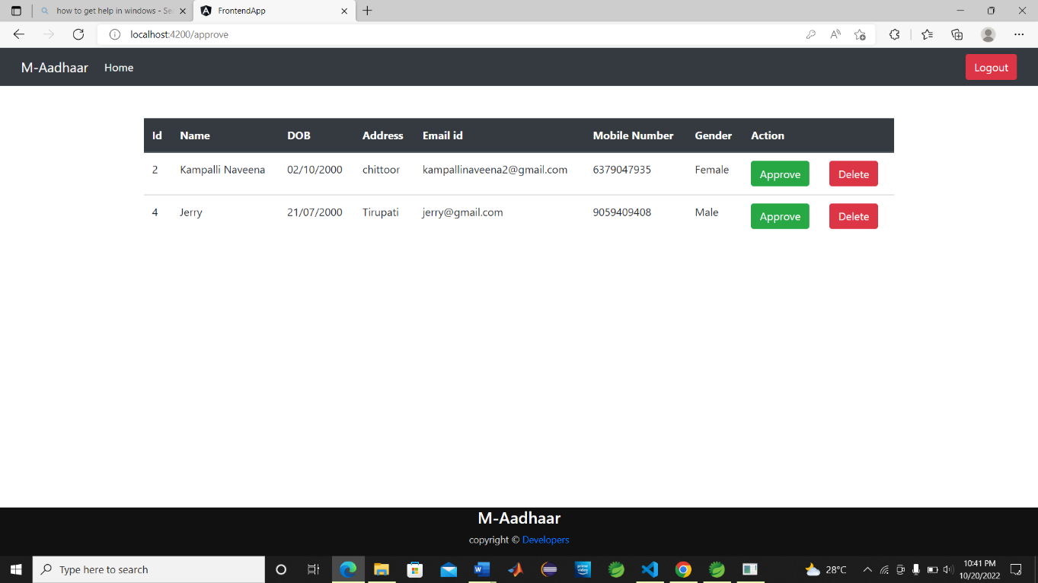

**If admin click delete button:**

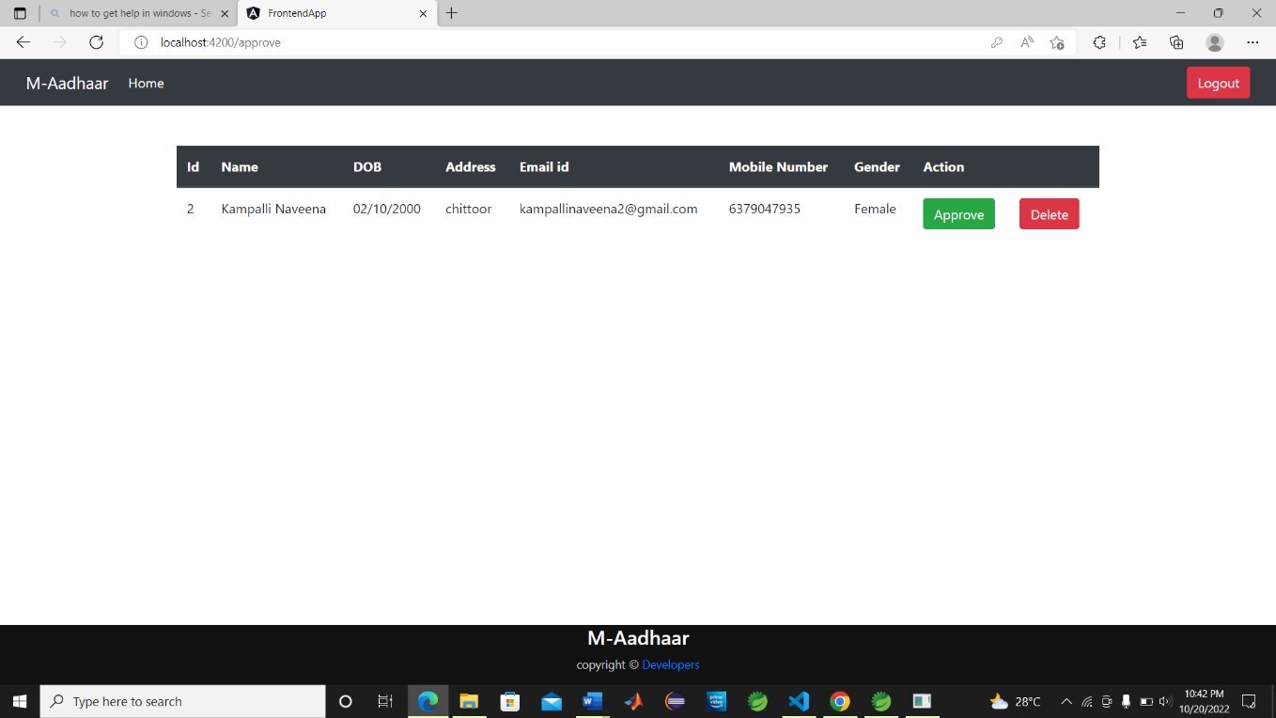

**If admin credentials are entered wrong:**

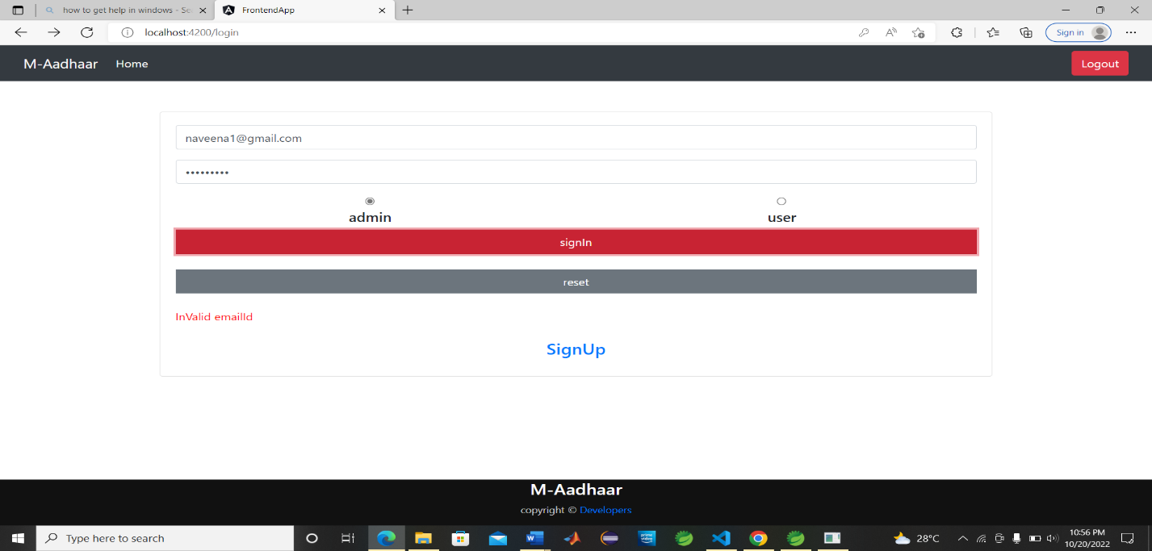

**Running test cases in testng:**

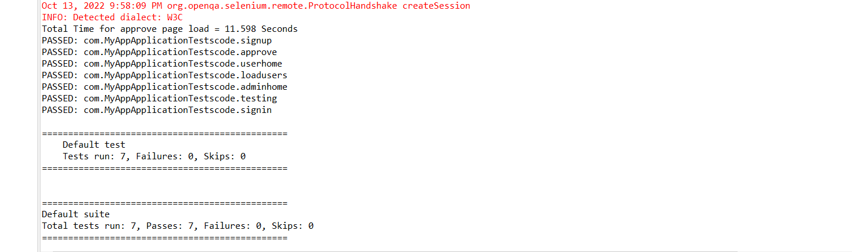

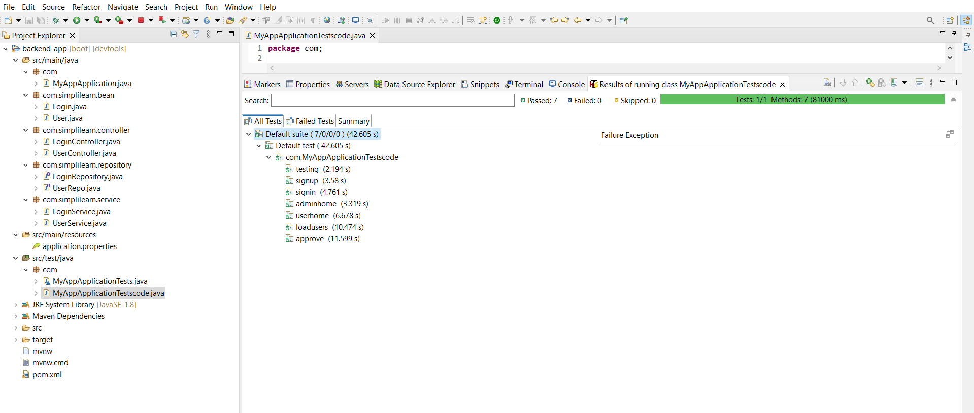

**Chrome browser is being tested automatically:**

